Chapter 5, Problem 48

The circuit in Fig. 5.80 is a differential amplifier driven by a bridge. Find v_{o}.
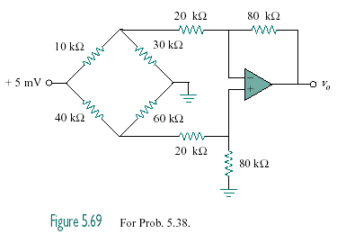

+10 mV

Figure 5.80
For Prob. 5.48.

